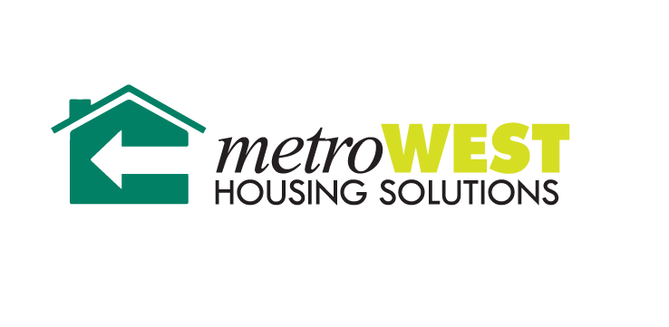

DECLARATION OF EMPLOYMENT LOSS

HEAD OF HOUSEHOLD NAME _________________________________________________

LAST 4 OF SOCIAL SECUITY NUMBER XXX-XX __________________

ADDRESS __________________________________________________________________

This is to certify that I, ____________________________, have ended employment at_________________________________________(Company Name).

My last day of work was ____/______/2020

By signing this form, I am certifying that I have no wage income; and I do not anticipate having wage income in the next 30 days. I understand that if I do gain any additional income that changes must be reported **within 10 days of the change**.

I/We certify that the information given to the Metro West Housing Solutions on household composition, income, net family assets and allowance and deductions is accurate and complete to the best of my/our knowledge and belief. I/We understand that we are required to report any changes in household composition, income, net family assets and allowances, and deduction in writing **within 10 days** of the change to Metro West Housing Solutions. I/We also understand that false statements or information are punishable under federal law as well as grounds for termination of housing assistance or tenancy. I/We have no objection to inquiries for the purpose of verification.

I we understand that if a resident submits fraudulent information to this agency or withholds relevant information from this agency, the resident will be charged back rent, may be terminated from assisted housing, and may be turned in for prosecution for violating a federal law.

______________________________________________ __________________________

Signature Date

**WARNING: TITLE 18, SECTION 1001 OF THE U.S. CODE STATE THAT A PERSON IS GUILTY OF A FELONY FOR KNOWINGLY AND WILLINGLY MAKING FALSE OR FRAUDULENT STATEMENTS TO ANY DEPARTMENT OF THE UNITED STATES GOVERNMENT.**

Alternative Formats of this Document are Available Upon Request

